



Program Demonstrating Single Inheritance
LAB MANUAL

Disclaimer: The content is curated from online/offline resources and used for educational purpose only
Program Demonstrating Single Inheritance

Objectives:
- To understand the concept of single inheritance in Python with a real-world example using employee data.
- To create a base class Employee and a derived class Manager that inherits from Employee.
- To demonstrate how the derived class inherits attributes and methods from the base class while also adding additional functionality specific to managers.
- To understand how Python’s Object-Oriented Programming (OOP) concepts like inheritance, method overriding, and attribute extension can be applied.
Problem Statement:
The task is to create a base class Employee that stores basic employee details like name, age, and salary. A derived class Manager will inherit from Employee and extend it with an additional attribute—department—to represent the department the manager oversees. The goal is to demonstrate how the Manager class can inherit from the Employee class and add its own functionality.
Procedure:
Task 1: Define the Base Class Employee
Task 2: Define the Derived Class Manager
Task 3: Instantiate Objects from Base and Derived Classes

Code:
Task 1: Define the Base Class Employee
The Employee class has a constructor __init__() to initialize the employee’s name, age, and salary.
The display_info() method returns a formatted string with the employee’s information.
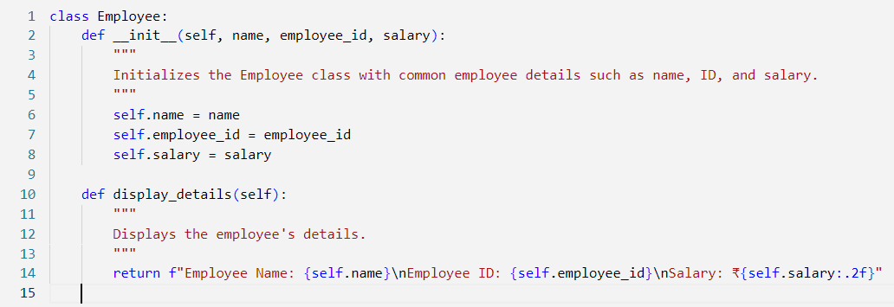

Task 1: Define the Base Class Employee

The Manager class inherits from the Employee class, adding a new attribute team_size to represent the number of people the manager supervises. The __init__() method in the Manager class uses super() to call the constructor of the Employee class to initialize common attributes.
The display_details() method is overridden to include team size while still displaying the general employee details using the base class method.
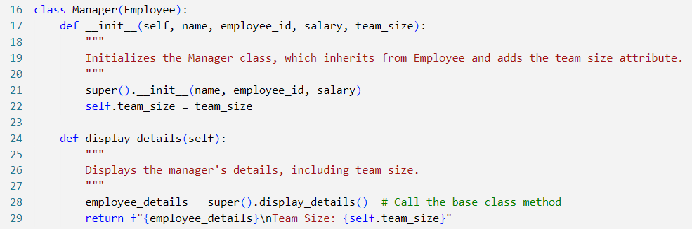

Task 3: Instantiate Objects from Base and Derived Classes
An object employee is created from the base class Employee with the name "Employee1", ID "E001", and salary of ₹50,000. Another object manager is created from the derived class Manager with the name "Manager1", ID "M456", salary of ₹80,000, and a team size of 10.
Both objects display their respective details using the display_details() method, with the Manager class showing the additional team size information.
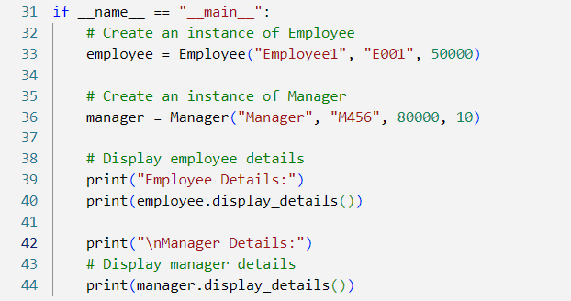

Output:
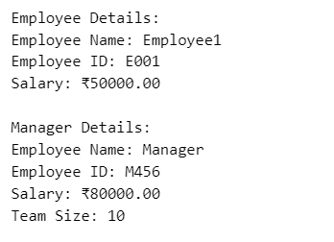

The Manager class inherits from the Employee class, demonstrating how a child class (or derived class) can reuse code from a parent class (or base class).

